//1.Write a program to check whether a person is eligible to vote (age ≥ 18).

import java.util.Scanner;

public class Main{
public static void main(String[] args){
Scanner sc = new Scanner(System.in);

System.out.println("Enter your age: ");
int age = sc.nextInt();

if (age < 18) {
System.out.println("You are not eligible to vote");
} else if (age >= 18) {
System.out.println("You are eligible to vote");
}

sc.close();
}
}

Sample Input | Sample Output
11 | 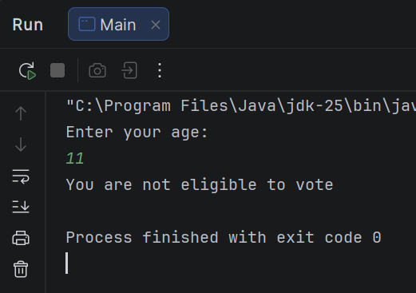
19 | 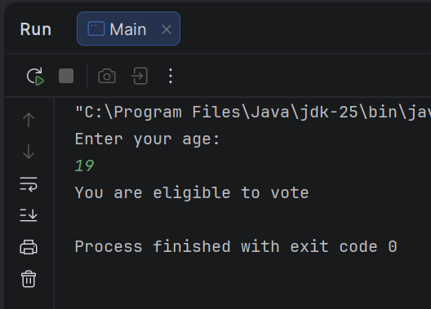

//2. Write a program to assign grades based on marks:
//80–100 → A, 70–79 → B, 60–69 → C, Below 60 → Fail
import java.util.Scanner;
public class Main {
public static void main(String[] args){
Scanner sc = new Scanner(System.in);
System.out.println("Enter your number: ");
int number = sc.nextInt();
if(number >= 80 && number <= 100){
System.out.println("Grade: A");
} else if(number >= 70 && number <= 79){
System.out.println("Grade: B");
} else if(number >= 60 && number <= 69){
System.out.println("Grade: C");
} else if(number <= 59){
System.out.println("Grade: Fail");
} else{
System.out.println("Wrong number");
}
sc.close();
}
}

Sample Input | Sample Output
75 | 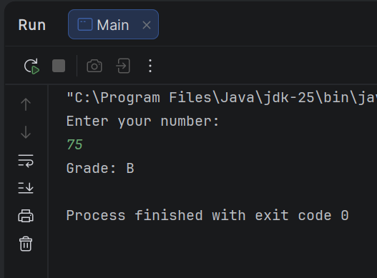
10 | 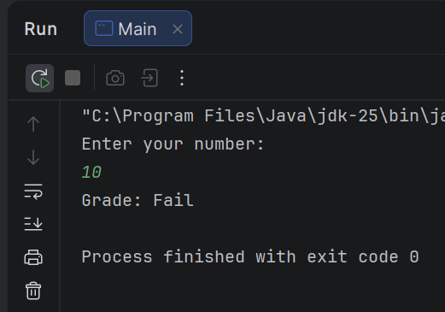

//Write a Java program to take a number n: If n is even, print 0; If n is odd, print the sum of digits of n
import java.util.Scanner;
public class Main {
public static void main(String[] args) {
Scanner sc = new Scanner(System.in);
System.out.println("Enter a number: ");
int n = sc.nextInt();
if (n == 1) {
System.out.println("Odd");
} else if (n % 2 == 0) {
System.out.println(0);
} else {
System.out.println("Odd");
}
}
}

Sample Input | Sample Output
10 | 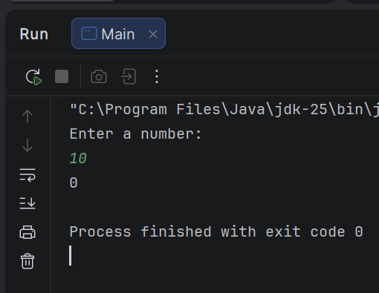
121 | 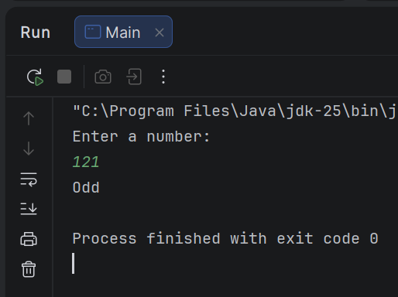

//4. Find the max and min of 3 numbers.
// a. Inside main, declare 3 integer variables and assign 3 different values.
// b. Implement the logic to find the max and min of those 3 values and print the values.
public class Main {
public static void main(String[] args){
int a = 10;
int b = 90;
int c = 30;
if(a > b && a > c){
System.out.println("Max of this 3 number is: " +a);
} else if (b > a && b > c) {
System.out.println("Max of this 3 number is: " +b);
}else{
System.out.println("Max of this 3 number is: " +c);
}
}
}

Sample Input | Sample Output
 | 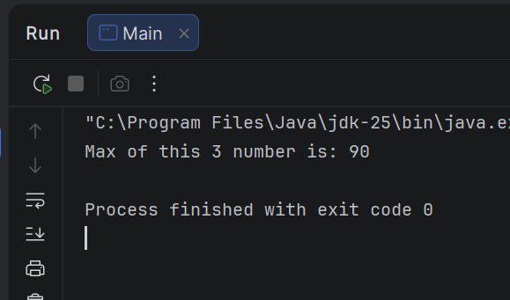

//5. Write a Java program to find the summation and average of 3 integer values.
import java.util.Scanner;
public class Main {
public static void main(String[] args){
Scanner sc = new Scanner(System.in);
System.out.println("Input three numbers: ");
float num1 = sc.nextInt();
float num2 = sc.nextInt();
float num3 = sc.nextInt();
float sum = num1 + num2 + num3;
System.out.println("Summation is = " +sum);
float avg = sum / 3;
System.out.println("Average is = " +avg);
sc.close();
}
}

Sample Input | Sample Output
5  10  15 | 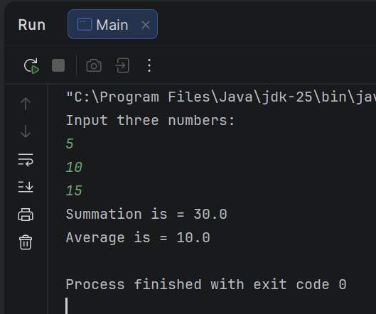
45  89  62 | 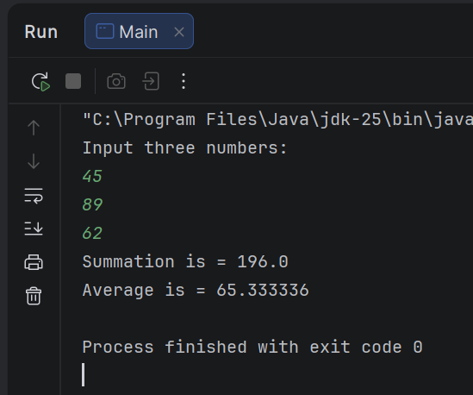

//6. Find the factorial of a given number.
public class Main {
public static void main(String[] args){
int num = 5;
int fact = 1;
for(int i = 1; i <= num; i++){
fact *= i;
}
System.out.println("Factorial = " +fact);
}
}

Sample Input | Sample Output
 | 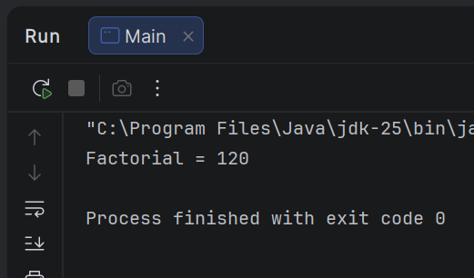

//7. Print all numbers between 1 and n that are divisible by 3 and 5.
import java.util.Scanner;
public class Main {
public static void main(String[] args){
Scanner sc = new Scanner(System.in);
int n = sc.nextInt();
for(int i = 1; i <= n; i++){
if(i % 3 == 0 || i % 5 == 0){
System.out.println(i);
}
}
sc.close();
}
}

Sample Input | Sample Output
20 | 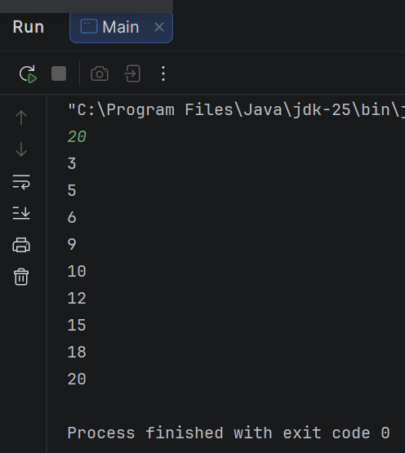
5 | 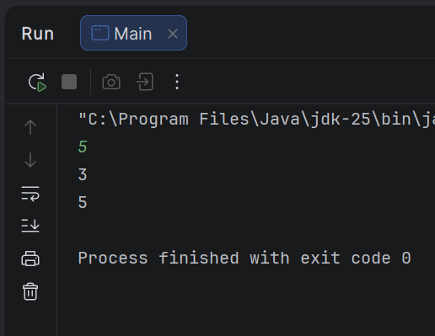

Lab 2 Classwork Tasks
//1. Write a Java application that will prompt the user to provide a number as input.
// Read input as a number and display the square of the number.
import java.util.Scanner;
public class Main {
public static void main(String[] args){
Scanner sc = new Scanner(System.in);
System.out.print("Input a number: ");
long n = sc.nextInt();
System.out.println(n*n);
sc.close();
}
}

Sample Input | Sample Output
25 | 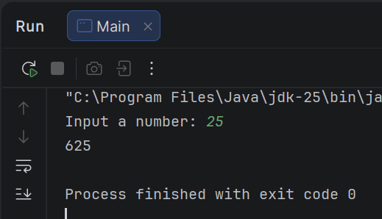
4 | 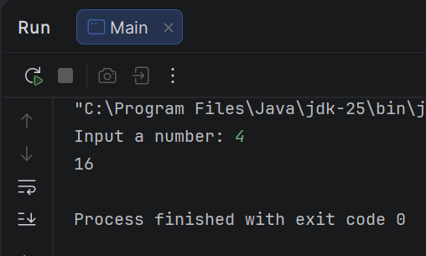

//2. Write a java program that will prompt the user to provide a number as input. Read input
//as a number and display whether the number is even or odd.
import java.util.Scanner;
public class Main{
public static void main(String[] args){
Scanner sc = new Scanner(System.in);
int n = sc.nextInt();
if(n % 2 == 0){
System.out.println("Even");
}else{
System.out.println("Odd");
}
sc.close();
}
}

Sample Input | Sample Output
25 | 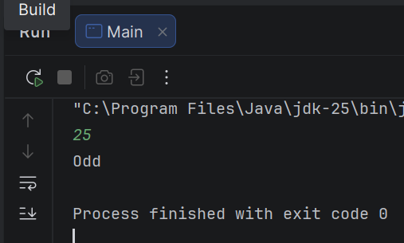
50 | 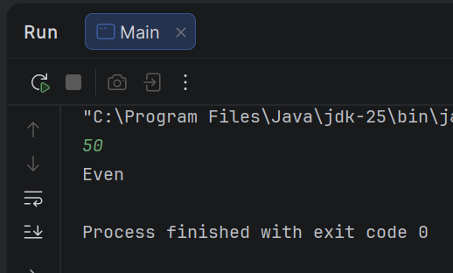

//3. Write a java program to determine whether a given number is prime or not.
import java.util.Scanner;
public class Main {
public static void main(String[] args){
Scanner sc = new Scanner(System.in);
int n = sc.nextInt();
boolean isPrime = true;
for(int i = 2; i < n; i++){
if(n % i == 0){
isPrime = false;
break;
}
}
if(isPrime == true){
System.out.println("Given number is Prime");
}else{
System.out.println("Given number is Not Prime");
}
sc.close();
}
}

Sample Input | Sample Output
57 | 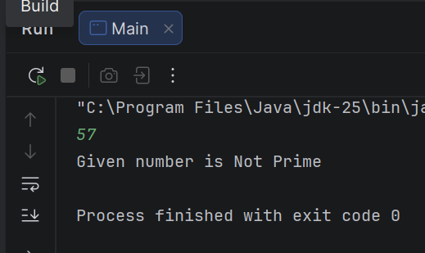
7 | 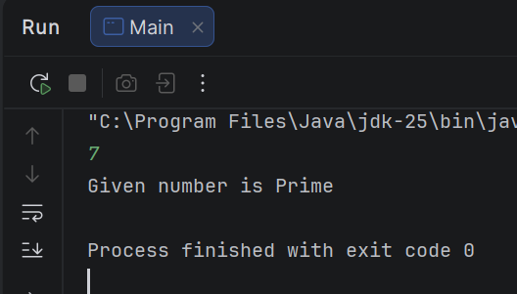

//4. Write a program that will take an integer number, and print the day of the week
//depending on the number. To find the day of the week, you need to divide the number
//by 7 and find the remainder. The day will have the following value depending on the
//remainder.
import java.util.Scanner;
public class Main {
public static void main(String[] args){
Scanner sc = new Scanner(System.in);
int n = sc.nextInt();
switch(n){
case 0:
System.out.println("Saturday");
break;
case 1:
System.out.println("Sunday");
break;
case 2:
System.out.println("Monday");
break;
case 3:
System.out.println("Tuesday");
break;
case 4:
System.out.println("Wednesday");
break;
case 5:
System.out.println("Thursday");
break;
case 6:
System.out.println("Friday");
break;
default:
System.out.println("Unknown");
}
sc.close();
}
}

Sample Input | Sample Output
5 | 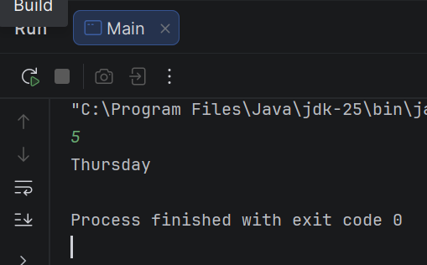

//5. Write a program that will take two integer numbers from user, and print the LCM of those
//numbers.
import java.util.Scanner;
public class Main{
public static void main(String[] args){
Scanner sc = new Scanner(System.in);
System.out.println("Enter the first number: ");
int num1 = sc.nextInt();
System.out.println("Enter the second number: ");
int num2 = sc.nextInt();
int max = (num1 > num2) ? num1 : num2;
int lcm = max;
for(int i = max; ;i++){
if(i % num1 == 0 && i % num2 == 0){
lcm = i;
break;
}
}
System.out.println("LCM Is = " +lcm);
sc.close();
}
}

Sample Input | Sample Output
15  20 | 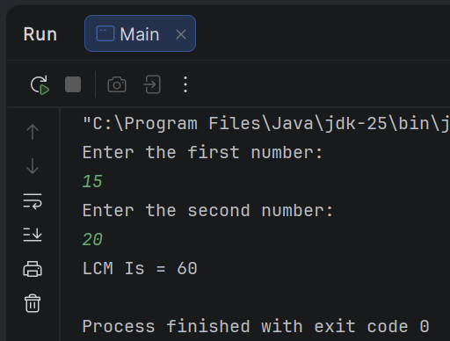

//6. Write a Java program that will take 10 numbers from user and only print the numbers
//(among those 10 numbers) that are divisible by 3 or 5 but not both.
import java.util.Scanner;
public class Main{
public static void main(String[] args){
Scanner sc = new Scanner(System.in);
int[] arr = new int[10];
for(int i = 0; i < 10; i++){
arr[i] = sc.nextInt();
}
for(int i = 0; i < 10; i++){
if((arr[i] % 3 == 0 || arr[i] % 5 == 0) && !(arr[i] % 3 == 0 && arr[i] % 5 == 0)){
System.out.println(arr[i]);
}
}
sc.close();
}
}

Sample Input | Sample Output
15  5  3  7  8  9  12  99  121  698 | 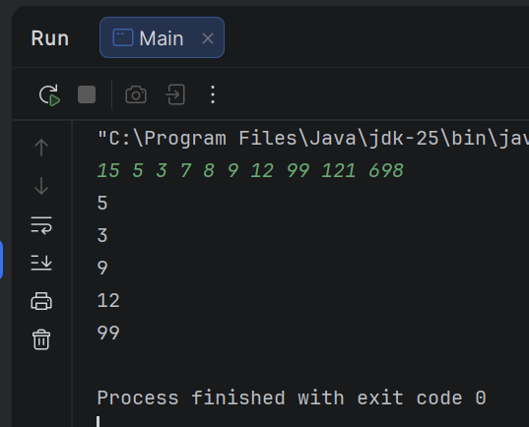

//7. Write a program in java to display the summation of the even digits of a number.
import java.util.Scanner;
public class Main {
public static void main(String[] args) {
Scanner sc = new Scanner(System.in);
int n = sc.nextInt();
int sum = 0;
int digit;
while (n > 0) {
digit = n % 10;
if (digit % 2 == 0) {
sum += digit;
}
n = n / 10;
}
System.out.println(sum);
}
}

Sample Input | Sample Output
25468731 | 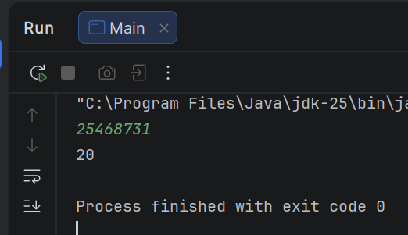
12345 | 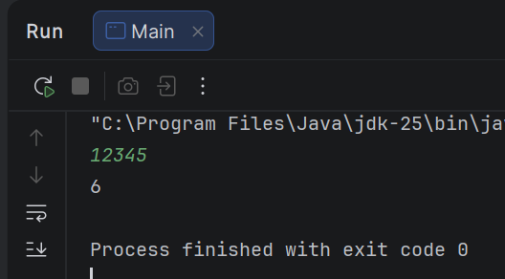

//2.8. Write a java program to print the Fibonacci series up to n th item. The value of n will be provided by the user as input
import java.util.Scanner;
public class Main {
public static void main(String[] args) {
Scanner sc = new Scanner(System.in);
int n = sc.nextInt();
int a = 1, b = 1;
for (int i = 1; i <= n; i++) {
System.out.print(a);
if (i < n) {
System.out.print(", ");
}
int next = a + b;
a = b;
b = next;
}
sc.close();
}
}

Sample Input | Sample Output
9 | 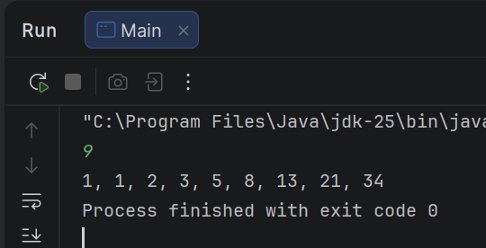
2 | 